Insert School Logo

Semester Two

Examination 2018

Question/Answer booklet

MATHEMATICS
METHODS UNITS 1 and 2

Section One:
Calculator-free

Student’s Name: _____________________________________
Teacher’s Name: _____________________________________

Time allowed for this section
Reading time before commencing work: five minutes
Working time for paper: fifty minutes

Material required/recommended for this section

To be provided by the supervisor
This Question/Answer booklet
Formula Sheet

To be provided by the candidate
Standard items: pens (blue/black preferred), pencils (including coloured), sharpener, correction tape/fluid, erasers, ruler, highlighters

Special Items: nil

Important note to candidates
No other items may be taken into the examination room. It is your responsibility to ensure that you do not have any unauthorised notes or other items of a non-personal nature in the examination room. If you have any unauthorised material with you, hand it to the supervisor before reading any further.

Structure of this paper

 | Number of questions available | Number of questions to be attempted | Working time (minutes) | Marks available | Percentage of exam
Section One  Calculator—free | 10 | 10 | 50 | 51 | 35
Section Two  Calculator—assumed | 16 | 16 | 100 | 99 | 65
 |  |  |  | 150 | 100

Instructions to candidates

- The rules for the conduct of Western Australian external examinations are detailed in the
Year 12 Information Handbook 2018. Sitting this examination implies that you agree to abide by these rules.

- Answer the questions according to the following instructions.

Show all your working clearly. Your working should be in sufficient detail to allow your
answers to be checked readily and for marks to be awarded for reasoning. Incorrect answers given without supporting reasoning cannot be allocated any marks. For any question or part question worth more than two marks, valid working or justification is required to receive full marks. If you repeat an answer to any question, ensure that you cancel the answer you do not wish to have marked.

It is recommended that you do not use pencil, except in diagrams.

- You must be careful to confine your responses to the specific questions asked and to follow any instructions that are specific to a particular question.

- Spare pages are included at the end of this booklet. They can be used for planning your responses and/or as additional space if required to continue an answer.
- Planning: If you use the spare pages for planning, indicate this clearly at the top of the page.
- Continuing an answer: If you need to use the space to continue an answer, indicate in the original answer space where the answer is continued, i.e. give the page number. Fill in the number of the question that you are continuing to answer at the top of the page.

- The Formula Sheet is not handed in with your Question/Answer Booklet.

Section One: Calculator–free 35% (51 marks)

This section has ten (10) questions. Attempt all questions. Write your answers in the spaces provided.

Spare pages are included at the end of this booklet. They can be used for planning your responses and/or as additional space if required to continue an answer.

- Planning: If you use the spare pages for planning, indicate this clearly at the top of the page.
- Continuing an answer: If you need to use the space to continue an answer, indicate in the original answer space where the answer is continued, i.e. give the page number. Fill in the number of the question(s) that you are continuing to answer at the top of the page.

Working time: 50 minutes

Question 1 (4 marks)

(a) If 3x − y = 4, what is the value of 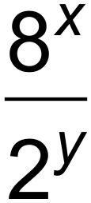? (2 marks)

(b) Simplify the following leaving the solution as a radical. (2 marks)
$\frac{u^{\frac{7}{2}}}{u^{\frac{5}{2}} × u^{\frac{1}{2}}}$

Question 2 (4 marks)

If for all values of x, and a + b = 8, what are the two possible values for c? (4 marks)

Question 3 (7 marks)

The tangent to a curve has the equation 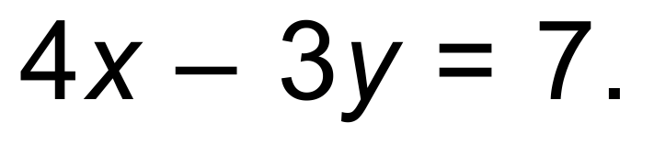

(a) Find the equation of the straight line that is parallel to the given tangent and which passes through the point C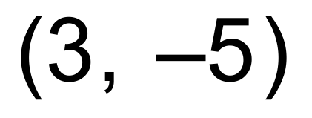, giving your answer in the form 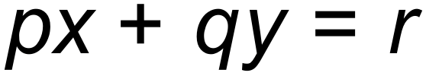 where p, q and r are integers. (3 marks)

(b) The tangent line intersects with the line with the equation 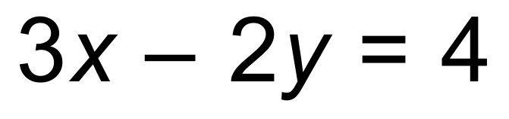 at the point D.
Find the coordinates of D. (2 marks)

(c) The point E with coordinates 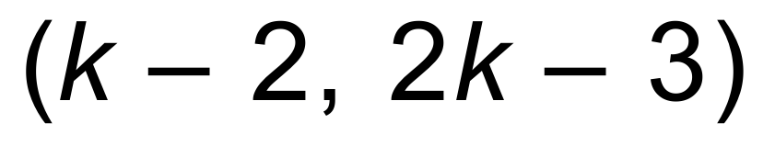 lies on the tangent line. Find the value of the constant k. (2 marks)

Question 4 (2 marks)

Simplify the following expression. Give your answer as an integer. 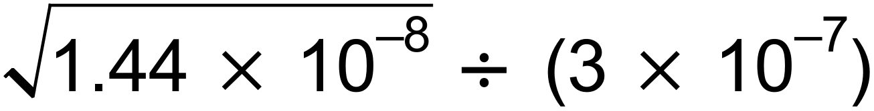

Question 5 (9 marks)

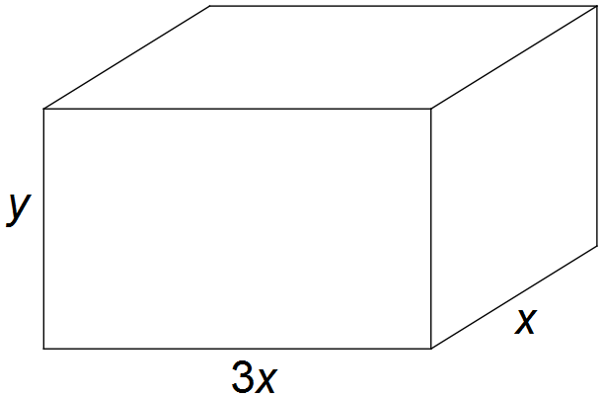The diagram shows a rectangular prism with sides of length x cm, 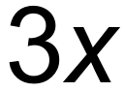 cm and y cm. The total surface area of the prism is 32 cm².

(a) Show that 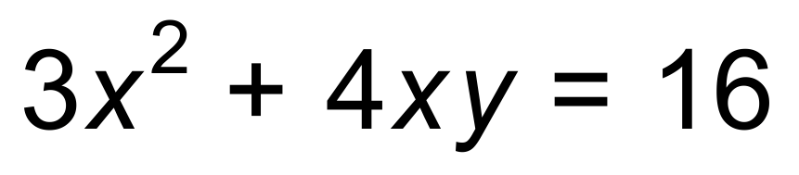. (2 marks)

(b) Hence show that the volume, V cm³, of the cuboid is given by 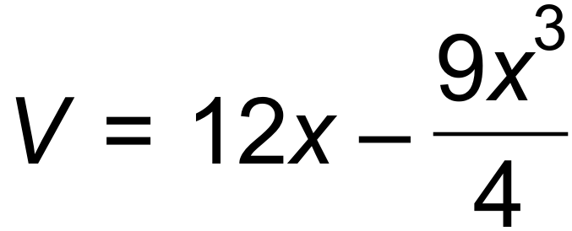. (2 marks)

(c) Show that a stationary value of V occurs when 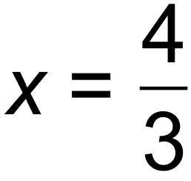. (3 marks)

(d) Use a sign table to determine whether V has a maximum or minimum value when .
(2 marks)

Question 6 (4 marks)

(a) Write the recursive formula to define the sequence for 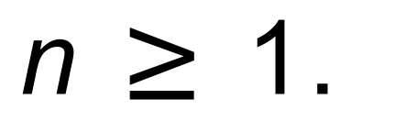
(2 marks)

(b) Determine the next two terms in the sequence described by the recursive formula:
T_{n+1} = 4T_{n} where T₁ = 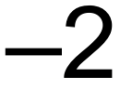 (2 marks)

Question 7 (5 marks)

The gradient function of a curve which passes through the point P (2, 3) is given by 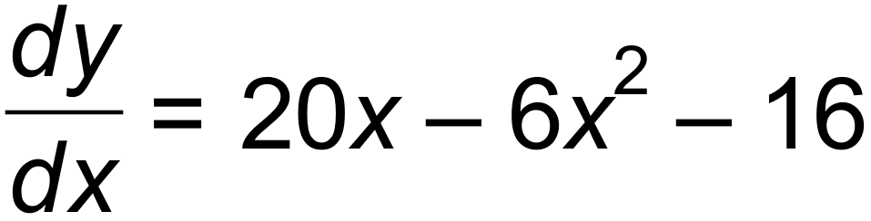.

(a) Determine the equation of the curve. (3 marks)

(b) Show that the tangent to the curve at P is parallel to the x$-$axis. (2 marks)

Question 8 (5 marks)

Consider an exponential function 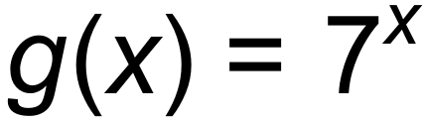.

(a) Describe the transformations required to obtain the function 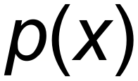 where 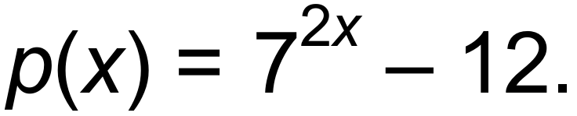
(2 marks)

(b) By forming and solving a quadratic equation, prove that 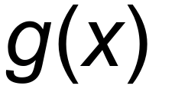and  intersect at exactly one point. (3 marks)

Question 9 (6 marks)

(a) Determine the equation of the tangent to the curve 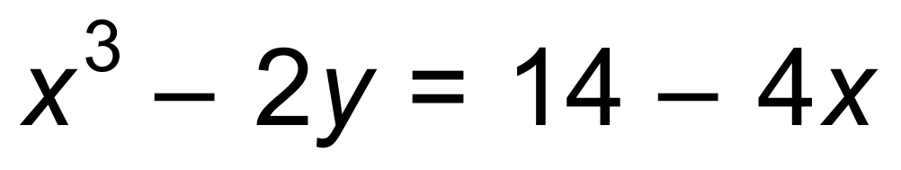 at the point (2, 1).
(4 marks)

(b) Draw the gradient function of the function below on the same axes. (2 marks)
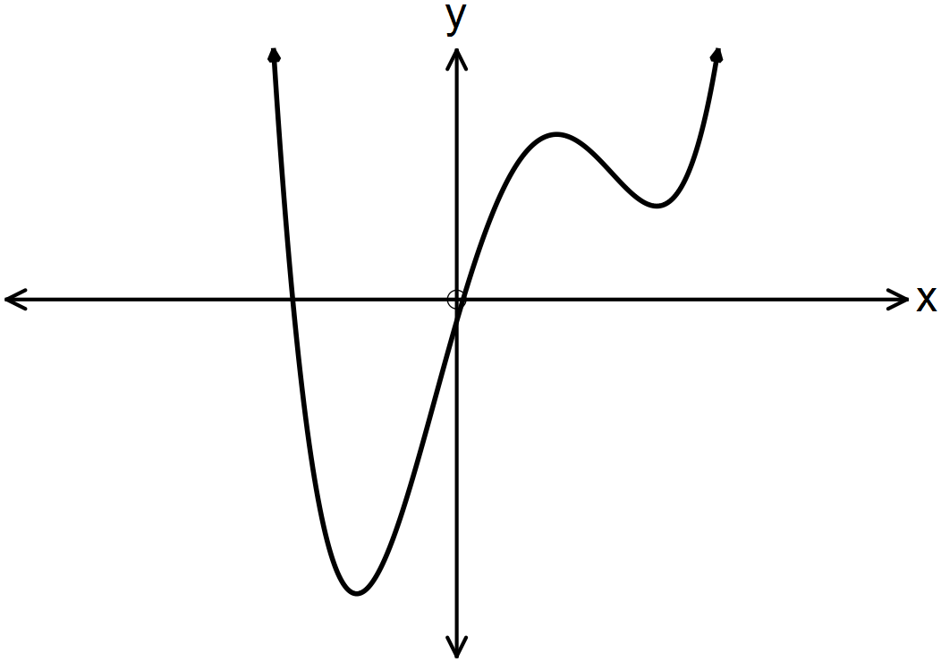

Question 10 (5 marks)

Consider the function 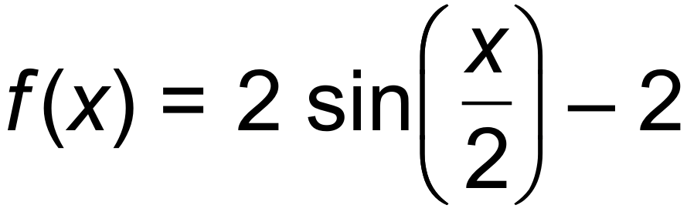.

(a) State the period and the amplitude. (2 marks)

(b) Sketch the graph on the axes below for 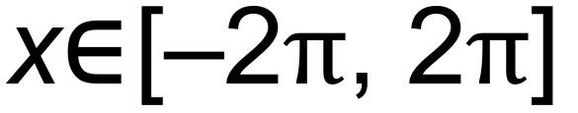 (3 marks)

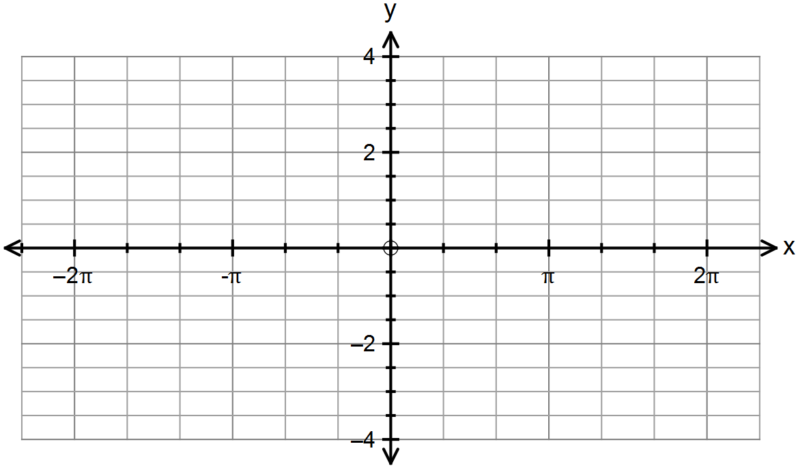

End of Questions
Additional working space

Question number(s): ……………………

Additional working space

Question number(s): ……………………

